


GARANTI VIRtUAL POS USER Interface
USER MANUAL

Contents
1 Application Start - 3 -
1.1 Login - 4 -
1.2 Home Page - 5 -
2 Merchant Admin - 6 -
2.1 Define User Role - 8 -
2.2 View And Update User Role - 9 -
2.3 Define Merchant User Function Authority - 10 -
2.4 View And Udate Merchant User Function Authority - 11 -
2.5 Define Merchant User - 12 -
2.6 View And Update Merchant User - 14 -
2.7 Merchant User Password/Keyword Management - 17 -
2.8 Define Merchant E-Mail - 19 -
2.9 Upload Merchant Logo - 20 -
2.10 Define Special Field - 21 -
2.11 3D Secure Key Exchange - 22 -
2.12 BIN Listing - 23 -
2.13 Define Source Based Security - 24 -
2.14 View And Update Source Based Security - 25 -
2.15 Define Blacklist - 26 -
2.16 View And Update Blacklist - 27 -
3 Merchant User - 27 -
3.1.1 Executive summary - 28 -
3.2 View Orders - 32 -
3.2.1 View Approved Orders - 37 -
3.2.2 View Pending Orders - 37 -
3.2.3 View Refundable Orders - 38 -
3.2.4 View Reversible Orders - 39 -
3.2.5 View Recurring Orders - 39 -
3.2.6 View Waiting Recurring Orders - 42 -
3.3 View Transactions - 43 -
3.4 Manual Transactions - 45 -
3.5 Mass Approvals - 47 -
3.5.1 Define New Job - 47 -
3.5.2 View All Job - 48 -
3.6 View Product - 49 -
3.7 End Of Day - 50 -
3.7.1 View Active End of Day - 51 -
3.7.2 View End of Day Reports - 51 -
3.8 Administration - 52 -
3.8.1 Password/Keyword Update - 52 -
3.8.2 BIN List - 53 -
3.8.3 Special Field Selection - 54 -
3.9 Define Source Base Security Definitions - 55 -
3.10 View And Update Source Based Security - 56 -
3.11 Define Blacklist - 57 -
3.12 View Blacklist - 58 -
3.13 View BonusPay Reports - 58 -

Application Start
GVPS (Garanti Virtual Pos System) is the web application that you can view transactions on your own terminals; analyze your merchants by using reports, order, sales and refund.

The steps to connect the GVPS platform are as below:

- Application login site is following URL: https://sanalposweb.garanti.com.tr/gvpsui/login/LoginStartEN.jsp the screen below will appear to login page.

- To access application, user name and password defined on the system will be entered. The procedures for login process will explain in “Login” section.

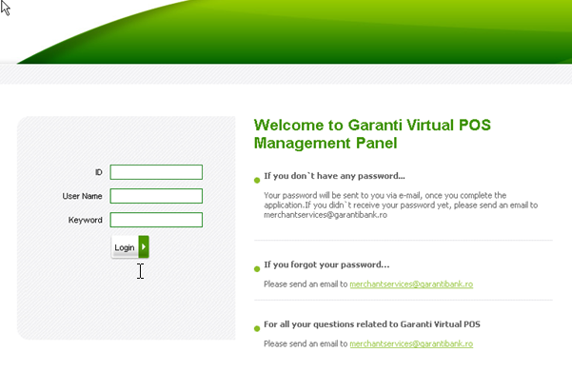

Login

- System administrator will set user name and password to system start beforehand. Username and password are transferred to merchants via e-mail and SMS.

- In order to login system, there are two authentication levels.
  - First level requires entering the merchant Id /firm Id on the ID field, username and password. When merchant id, username and keyword are typed correctly, ‘Login’ button is clicked.
  - If the first level passed successfully, second level requires password.

- If the password is authenticated, logging in is successful. The home page will appear.
Warning: For both of the login levels, logging in three times with invalid account info, will lock the user account which would be reset only by systems administrator.

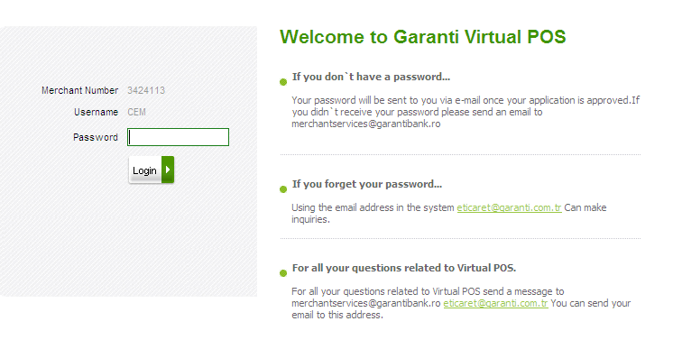

Home Page
Main menu: Different functions of the applications are piled up according to profile level.

Available function of menu steps viewed here will differ on user logged in. Merchant admin and merchant users defined on the platform and matched the relevant profiles. User and profile definitions are explained in details in following sections.

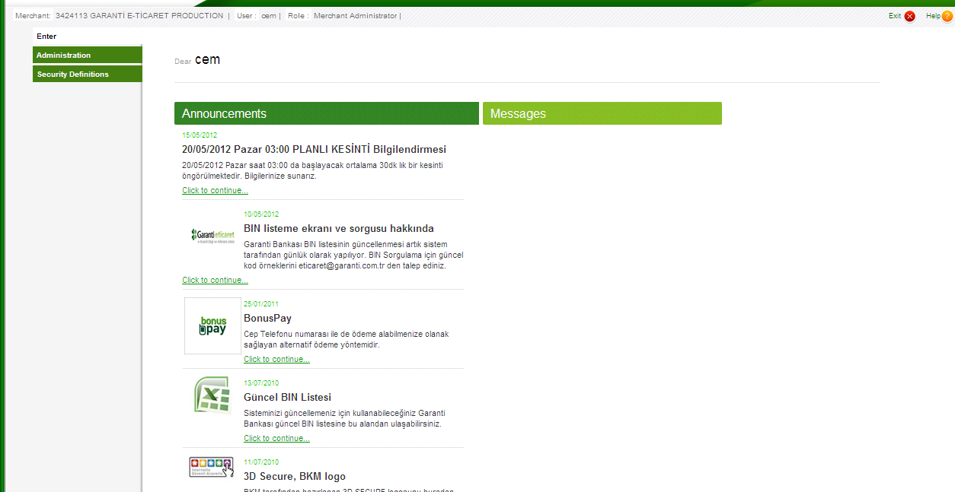

Merchant Admin
Merchant admin’s user name and password are defined on bank side. Merchant admin users authorized to sub user’s authentication limits or refer the profile defined before.

Home page shows administration and security definitions menu for merchant admin.
Main menu contains announcements and messages about the new features added to GVPS or briefing for functionality of menus. Announcements and messages are managed by Garanti admin users. (Garanti admin users are explained in Garanti admin User Manual)

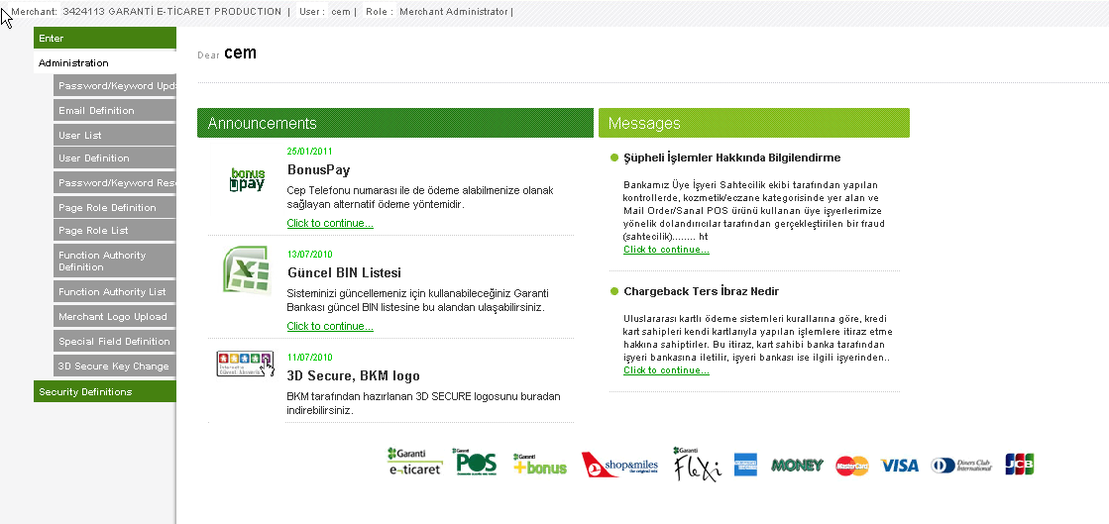

GVPS provide a parametric platform to edit and update parameters that can easily handle using GVPS user interfaces. The definition operations grouped under ‘Administration’ and ‘Security Definition’ menu.

Administration menu covers the following sub menus:

  - Password/Keyword Update
  - Email Definition
  - User List
  - User Definition
  - Password/Keyword Reset
  - Page Role Definition
  - Page Role List
  - Function Authority Definition
  - Function Authority List
  - Merchant Logo Upload
  - Special Field Definition
  - 3D Secure Key Change

Security definition menu covers the following sub menus:

  - Source Based Definition
  - Source Based Definition Listing
  - Blacklist Definition
  - Blacklist

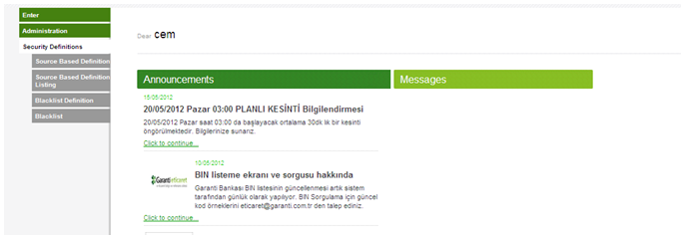

Define User Role
GVPS UI is user based application. The menu operations are allowed and defined by user profiles. The steps to follow when defining a new user profile is as follow:

    - After successful login to GVPS application, click the ‘Administration’ menu tab on the left side.
    - Choose ‘Page Role Definition’ option.
    - Role type set as ‘Merchant Definitions’ by default and cannot be change.
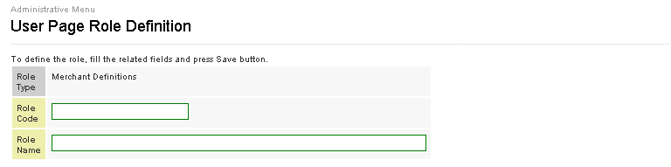

    - Role code: Host name for role definition.
    - Role name: Explanation of for role definition (e.g. Full Right, Limited Right)
    - When role code and name values are completely entered, select the menus you want the profile to be authorized. The menu list is listed below on the same screen. You can click on those you want to add into the profile authorization list.
    - The user profile is set by clicking ‘Save’ button.

    - To view and update the user profile definition on GVPS ‘Page Role List’ sub menus must be chosen. Please see “View And Update User Role” section .

View And Update User Role
There are many user profiles defined on GVPS platform. To view and edit definitions;
- Click the “Administration” menu tab on the left side.
- Choose “Page Role List” option under “Administration” menu.
- “User Page Authority Listing” screen will be viewed as below. You can find short data of the user profiles including role code, role name, role type and status (closed or active)of the users.

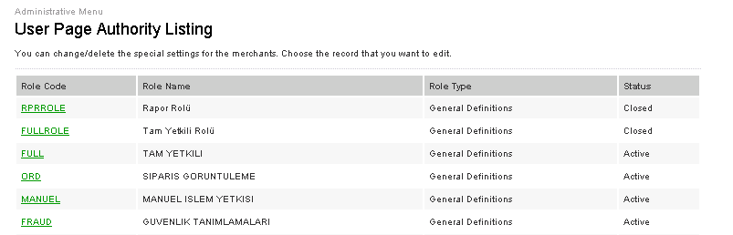

- When clicked any of the user profiles listed (over green link label), you will be directed to the detailed information page for the profile. As seen on the screenshot below you can view details of the user profiles and update only role name and status. You cannot update authorized screen list for the user profile.
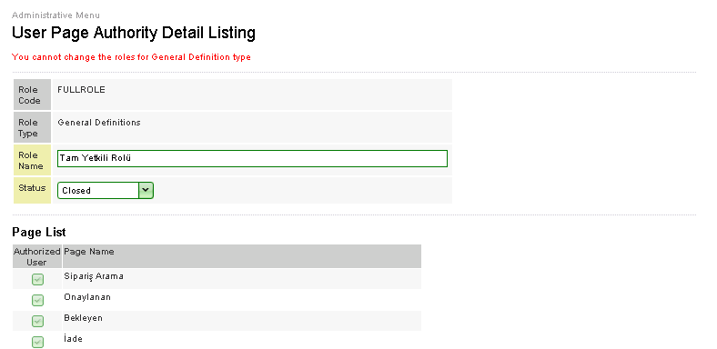

- Merchant cannot update the role definition defined by bank side. They can only view. In order to update role definitions, Merchant must define new one to be valid instead of general profile definition.

- Any change made on a profile definition will affect all the users defined on the same profile.

Define Merchant User Function Authority
There are many function parameters used for provision authorized user profiles. You can define function authority for group of merchants instead of one by one definition procedure. To define the function authority you can follow the steps below:
- Click the “Administration” menu tab on the left side.
- Choose “Function Authority Definition” option.
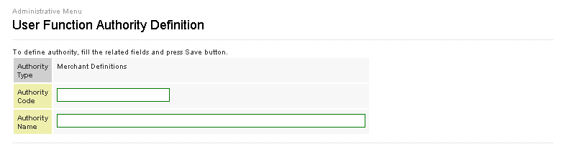
- Authority code: short name of authority definition (e.g FullAuth)
- Authority name: Explanation of for authority definition(e.g. Full authorization)
- When authority code and name values are completely entered, select the functions you want the profile to be authorized. The menu list is listed below on the same screen. You can click on those you want to add into the profile authorization list.
- The user profile is set by clicking ‘Save’ button.
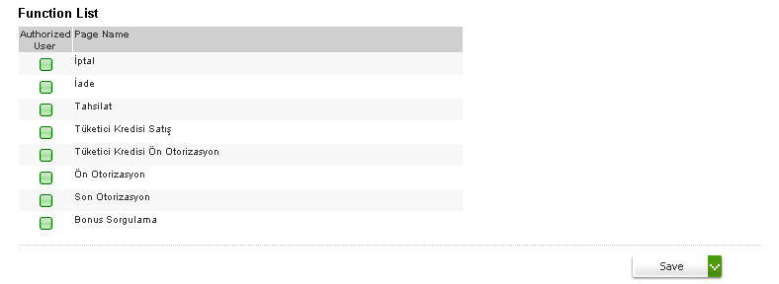
- To view and update the user profile definitions on GVPS, “Function Authority List” sub menu must be chosen. Please see “View and update merchant user Function Authority” section.

View And Udate Merchant User Function Authority
There are many authority codes defined on GVPS platform. To view and edit definitions;
- Click the “Administration” menu.
- Choose “Function Authority List” option.
- “User Function Authority Definition” screen will be viewed as below. You can find short data of the authority code of user profiles; authority code, authority name, authority type and status(active , closed)
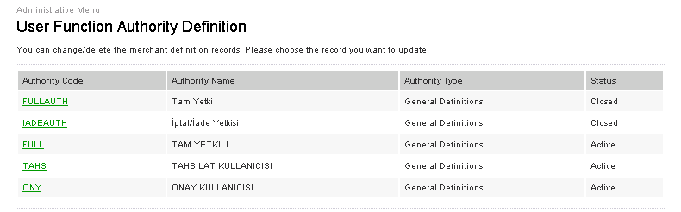
- When clicked any authority code of listed (over green link label), you will be directed to the detailed information page for the user.As seen on the screenshot below you can view authorized function list and update only authority name and status. You cannot update authorized screen list for the user profile.
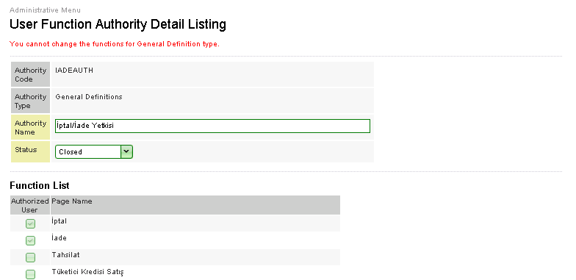

- Merchant cannot update the role definition defined by bank side. They can only view. In order to update function definitions, Merchant must define new one to be valid instead of general profile definition.

- Any change made on a function authority definition will affect all the users defined under the same authority code.

Define Merchant User
There two types of role definition one of them is for Page role definition and the other one is function definition. By defining page role you can decide which menus show on the left side and authorized by user profiles. Function definition will explain in “Define Merchant User Function Authority” section.

In order to define a new user to use the GVPS UI application, you must follow the steps below.
- Click the “Administration” menu tab on left side.
- Choose “User Definition” option.
- There are two steps to complete the definition of the new user.
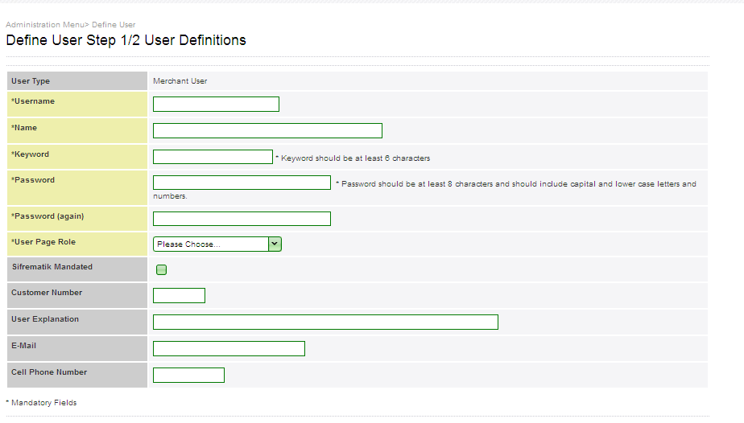
- User type set as ‘Merchant User’ by default and cannot be change.
- The fields in yellow (Username, Name, Keyword, Password and Password (Again) are mandatory to be filled in.
- Keyword must contain minimum 6 characters.
- Password must contain minimum 8 characters; having minimum one capital letter, one lower, case letter and a numeric character. Otherwise, the password will not be accepted.
- When user system data is completed, user profile must be chosen among those listed in “User Page Role”.
- Sifrematik mandated: User can login password dynamically produced on şifrematik instead of stably produced one. If the user wants to use dynamic password then the button must be selected.
- Customer number: customer identification number assigned by bank.
- Sifrematik mandated, customer number, User explanation, e-mail and cell phone number may be supplied additionally in the related fields.
- To pass the next step, click “Next Page” button.
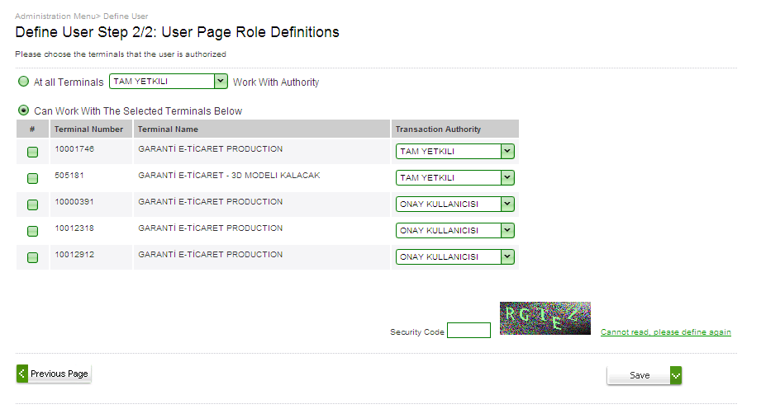
- In the second step, you can define the user authorized terminals.
- When you select the first condition, you must be chosen among those listed in “User Page Role”, so you can define same role for all terminals interconnected to merchant.
- When you select the second condition, you can define different role for each terminal by ticking bullets or give authorization for any terminals.
- Enter the security code.
- The application user is set by clicking “Save” button.
- To view and update merchant user information on GVPS, “User List” sub menu must be chosen. Please see “View and Update Merchant User” section.

View And Update Merchant User
There may be many Merchant users defined on GVPS platform. To view and edit user information, you can follow the steps below
- Click the “Administration” menu tab on the left side.
- Choose “User list” menu option.
- “User list” screen will be viewed as below. The list of the merchant users belong session owner user. You can find short data for the users; including user name, ID, name, user explanation, user type, and user status (active and closed) of the users.
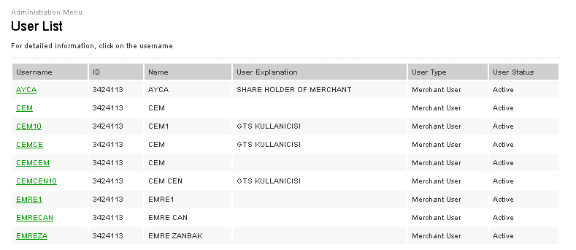
- When clicked any user of listed (over green link label), you will be directed to the detailed information page for the user.As seen on the screenshot below you can view further information for the user, including e-mail ,cell phone number , create date,create user,custımer num, sifrematik mandated value setted, last login time and last password change (in terms of date and time ).
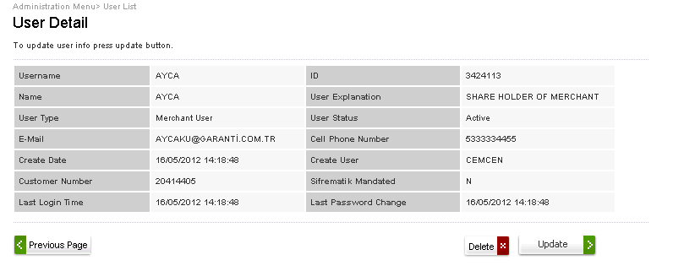
- You can remove the user definition records by clicking the “Delete” button.
- You can update the user definition by clicking the “Update” button on the same screen. You will be directed to the user update page seen below.
- You can update all parameters defined before in two steps.
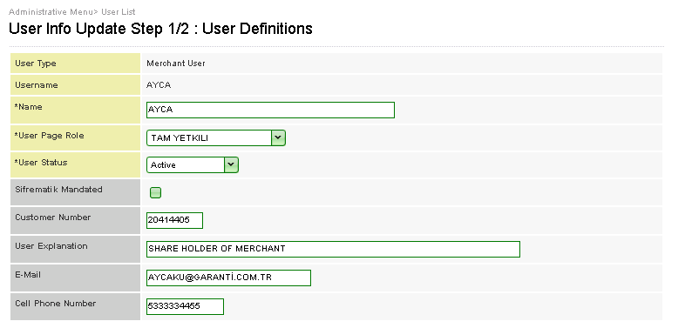

- Yellow field is mandatory as define page.
- You must save your updating actions by clicking “Save” button for each page.
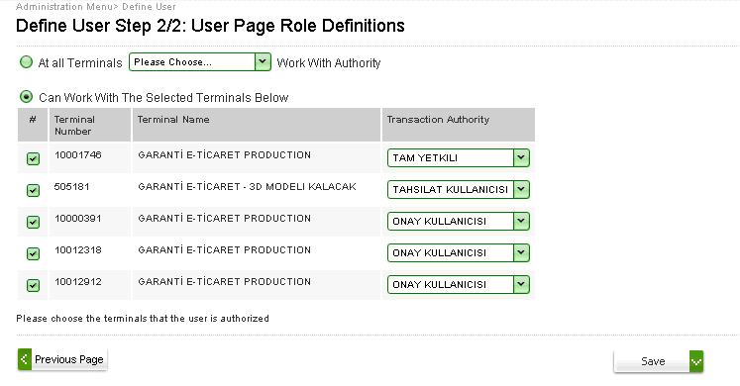

Merchant User Password/Keyword Management
Two options are supplied for user password management
  - Password /keyword reset
  - Password / keyword change
The steps for both of the operations are explained below.

- Password change operation can be handled only for the session owner user (user logged in at that moment). To change your password /keyword, click “Administration” menu tab on the left side.
- Choose “Password /keyword Update” menu options.
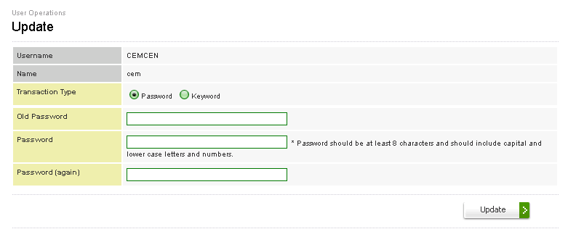
- Select the transaction type wanted to update value.
- After entering the old and new password values, click “Update” button. If you have follewed the password format rules for the new password, the password shoul be updated succesfully.
- Password reset operation can be handled for all the GVPS users. When password/keyword is locked or forgotten, authorized user may reset them.
- To reset a user password ,click the “Administration” menu tab on the left side.
- Choose “password/keyword Reset” the screen below will be appeared and GVPS users will be listed.
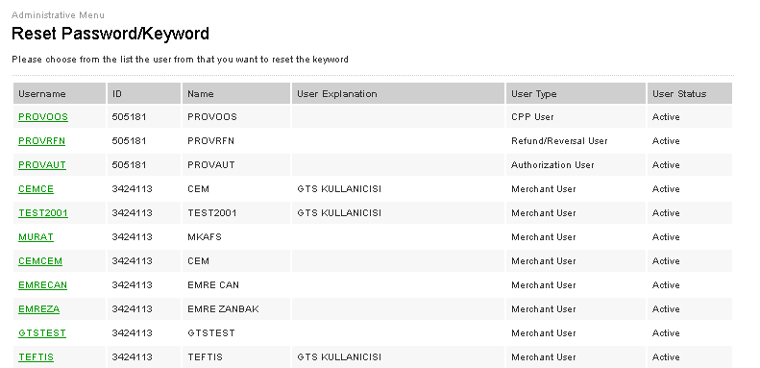

- Choose the user whom you want to reset password, by clicking the green link label.
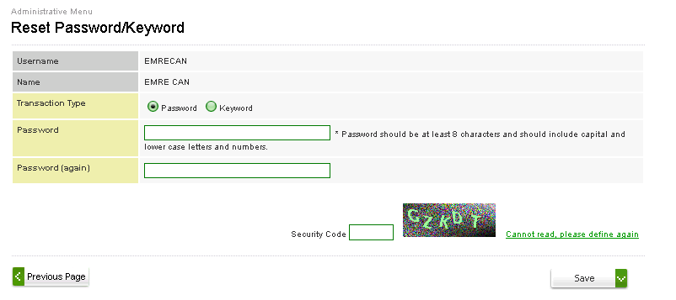
- Entering the new password for two times and security code, click the “Save” button. The password is reset, if the new password is compatible with password format defined above.

Note: The Update and reset procedures are the same for password and keyword.

Define Merchant E-Mail
Merchant admins can collect the e-mail addresses for each merchant member whom sent informative e-mails about GVPS. To collect the e-mail addresses, you can follow the steps below.
- Click the “Administration” menu tab on the left side.
- Choose “E-mail Definition” menu option.
- “E- Mail Definition” screen will be viewed as below.
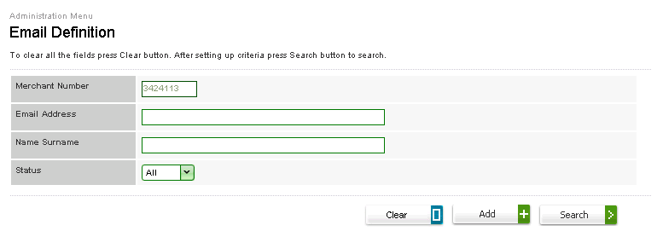
- Merchant number is filled with session owner merchant number.
- After entering a valid e-mail address and name – surname, click “Add” button.
- You can list all e-mail addresses defined before by clicking “Search” button on the same screen.
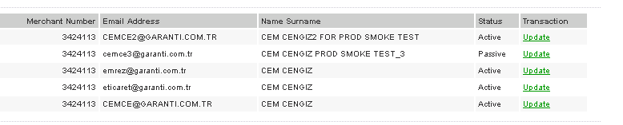
- When clicked any of the records listed (over the green update link label), you will be directed to the update page for the e-mail records. As seen on the screenshot below.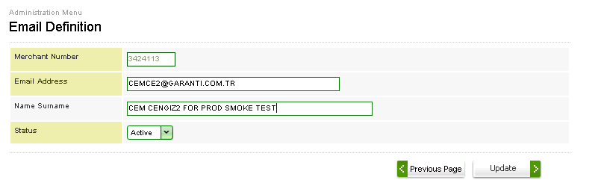
- You can update e-mail definition details (e-mail adress , surname name , and status (active,passive )by clicking the “Update” button.

Upload Merchant Logo
To show merchant own logo top of the left corner, you can follow the steps below.
- Click the “Administrator” menu tab on the left side.
- Choose “Merchant logo Upload” menu option.
- “Upload Logo” screen will be viewed as below.

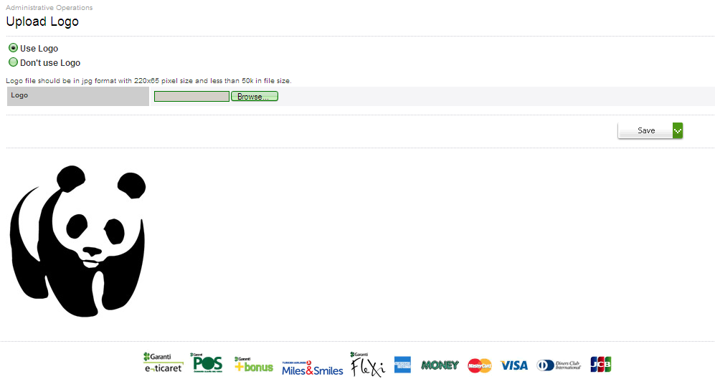

- When you select the “Use Logo” option, you must be browse and choose merchant logo.
- You can upload the logo browsed by clicking the “Save” button,then the logo can visible for all merchant screen.
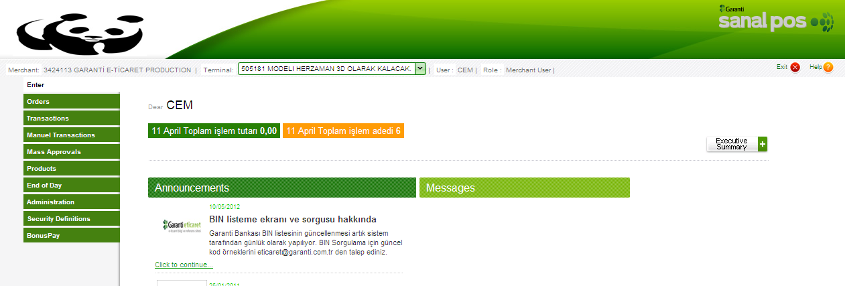
- You can remove the logo by selecting “Don’t Use Logo “option.

Define Special Field
There are ten fields defined to transport data from merchant side to GVPS platform and oppositely. To transport these fields to display on listing screens, you can follow the steps below.

- Clicked the “Administrator” menu tab on the left side.
- Choose the “Special Field Definition” option.
- Special field definition screen will be viewed as below. You can find list of the field definition for selected terminal.
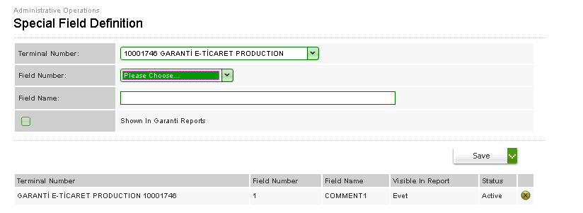
- You need to define special field for each terminal one by one, terminal number must be chosen among those listed.
- Select the field number.
- After entering the field name, you can save special field definition for related terminals
- “Shown in Garanti Reports” field is optional to display data defined as special on Garanti ftp reports. This option can use for only first field definition.
- Click “Save” button.

3D Secure Key Exchange
When 3D transactions occur on GVPS, merchants use the 3D secure key in hash calculation. 3D secure key stored in MPI Application. Regards to merchant user doesn’t achieve to MPI application to update the 3D secure key, merchant admin users is authorized for updating the key on “3D Secure Key Change” .

To update the 3D secure key , you can follow the steps below.

- Clicked the “Administrator” menu tab on the left side.
- Choose the “3d Secure Key Change” option.
- “3D Secure Key Change” screen will be viewed below

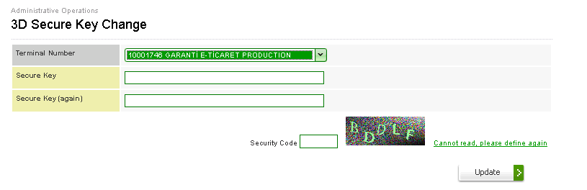
- Select the terminal you want to update its secure key.
- After entering the new secure key for two times and security code values click the “Update” button. The secure key is updated, if the new secure key is compatible with format.

BIN Listing
Merchants store the BIN values on their systems. When transaction request is sent, merchant can split transactions to understand which bank card used, whether transaction will be installed or not therefore merchant can decide where transaction will continue.

To view the list of Garanti and BonusNet own BIN data, you can follow the steps below.

- After successful Login to GVPS application, click the “Administration” menu tab on the left side.
- Choose the “BIN list” option.
- “Bin Listing” screen will appear below.

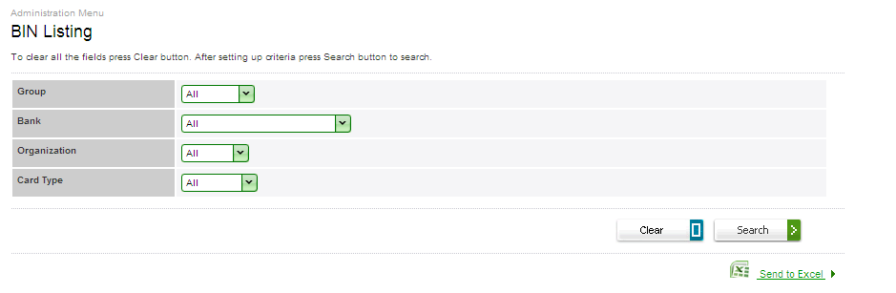
- Choose the group among those listed, given below
  - Garanti
  - Bonusnet*
- You can choose the Bank which is the members of the BONUS brand.
- You can choose the organization you want to view lists of.
- You can choose the card type you want to view lists of.
- After all selection is completed, you will see the list of BIN matched with your criteria.
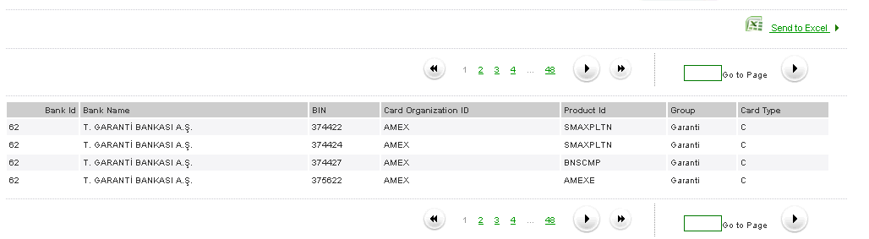

- You can transfer the BIN list to excel by clicking the “Send To Excel” button on the same screen.

* Bonusnet allows members (banks or financial institutions) to use Bonus brand on their credit cards or/and their merchants. Bonusnet members can be issuer or/and acquirer

Define Source Based Security
Merchant admin is authorized to define security definition. There are two options are supplied for security definitions
- Source based security definition
- Blacklist definition
You can define the number of transactions or total amount of transactions for per day, per week or per month for each terminal. Limit of the transactions can be defined based on the IP, card number and BIN. To define Source based security conditions you can follow the steps below

- Click the “Security Definitions” tab on the left side.
- Choose the “Source Based Definitions” options.
- “Source Based Definition” screen will be viewed as below.
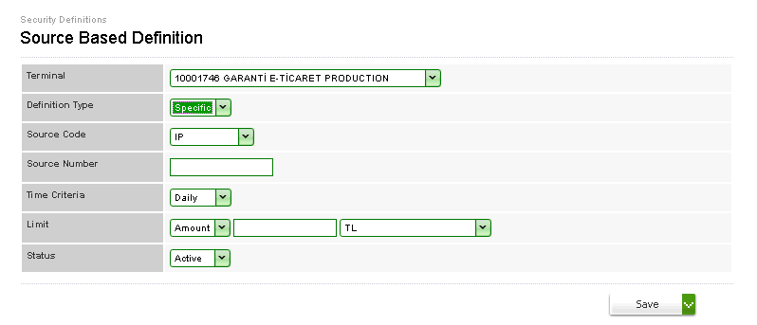
- You can chose one of the definition type, given below
  - General : To define working conditions for selected source code
  - Spesific : To define working conditions for one the source code . When you select the definition type as specific , you must be enter value for source number field.
- You can choose one the source code which you want to define working conditions definitions of , given below
  - IP
  - Card number
  - BIN
- After all value selection, you can save you definitions by clicking “Save”
button.

View And Update Source Based Security
To list the source based security definition, you can follow the steps below.

- Click the “Security Definition” tab on the left side.
- Choose the “Source Based Definition Listing” option.
- “Source Based Definition Listing” screen will appear below. You can list the source based definition based on the terminal.
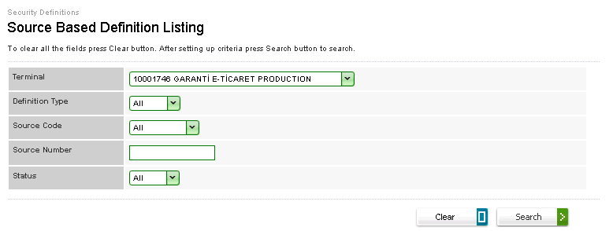
- Select the terminal which you want to view source based definition lists of.
- Choose the value for definition type , source code and enter source number(the selection of value for these field is optional)
- After all selection is completed, you can list the source based definitions by clicking “Search” button, if there are any.
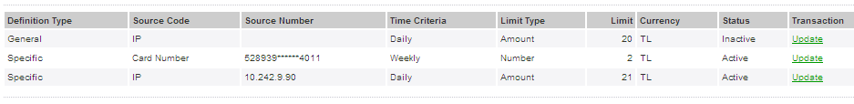

- When clicked any of the records listed (over the green update link label), you will be directed to the update page for the source based definition records. As seen on the screenshot below.
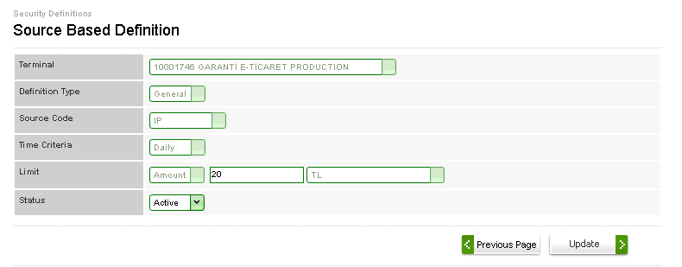

- You can only update limit and status value by clicking “Update” button.

Note: You cannot remove the source based definition already defined. To update the working condition for source code you need to set the status as “Inactive” and redefine the working conditions on “Source Based Definition” menu.

Define Blacklist
You can prevent the any transaction based on source code (IP, card number). In order to define whether source code in blacklist or not, you can follow the steps below.

- Click the “Security definitions” tab on the left side.
- Choose the “Blacklist Definition” option.
- “Blacklist Definition” screen will appear below.
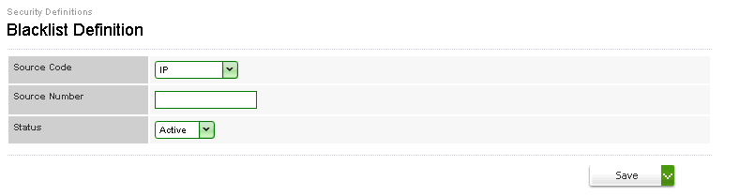
- You can choose source code which you want to prevent the any action of.
- You can enter the specific source number
- After status selection , click the “Save” button.

View And Update Blacklist
- To check whether a source code is in blacklist or not, choose “Blacklist” option under “Security definitions” menu.
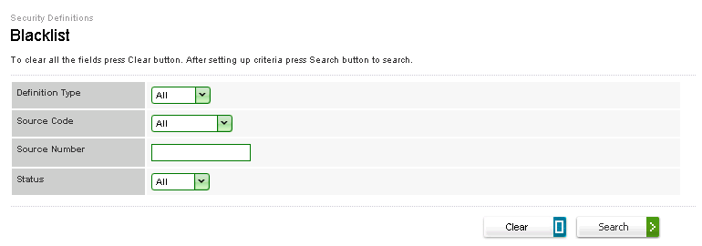
- Enter the definition type you want to search
- Enter the source code you want to search in specific value
- Enter the blacklist status (in blacklist or not )
- Click the “search button , and then the blacklist is listed.

Note: You cannot remove the blacklist definition already defined. To update the working condition for source code you need to set the status as “Inactive” and redefine the working conditions on “Blacklist Definition” menu.

Merchant User
Merchant user is authorized by merchant admin and they connect the GVPS platform with the same URL is following:
https://sanalposweb.garanti.com.tr/gvpsui/login/LoginStartEN.jsp the screen below will appear to login page.
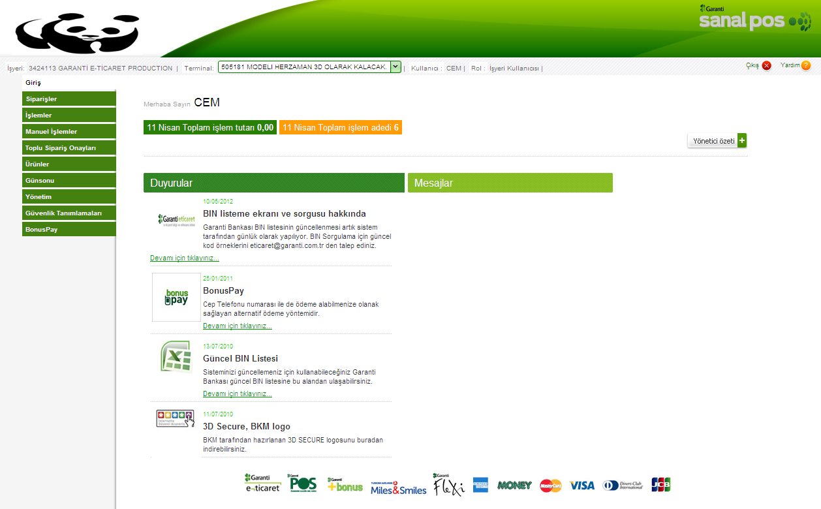

- Top of the home page shows the login information for session owner user in terms of merchant number, user name, and user role.
- You can select the terminal among those listed in “Terminal”. You can only go through your actions for selected terminal.
- Home page shows total transaction amount and total number of transactions for the previous day.
- There is an “Executive Summary” button on the right side of the main page. The details of the executive summary will explain in “Executive Summary” section.
- Content of the Announcement and Messages are not standard for all users. It depends on authorization definitions of Announcement and Messages for user profiles.

Executive summary

“Executive Summary” button provides two option to view transaction reports
- Transaction Details
- Transaction Distribution

  - Transaction Details

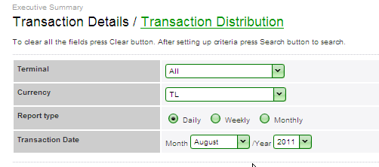
- You can display the transaction details for either a specific terminal or all terminals.
- You can choose one of the currency code , given below
  - TL
  - USD
  - EUR
  - JPY
  - GBP
- You can choose report type you want to see the reports
- You can choose the time period which you want to see the reports of.
- By clicking the “search” button, you can display the graphical reports for transaction amount and number of transaction.
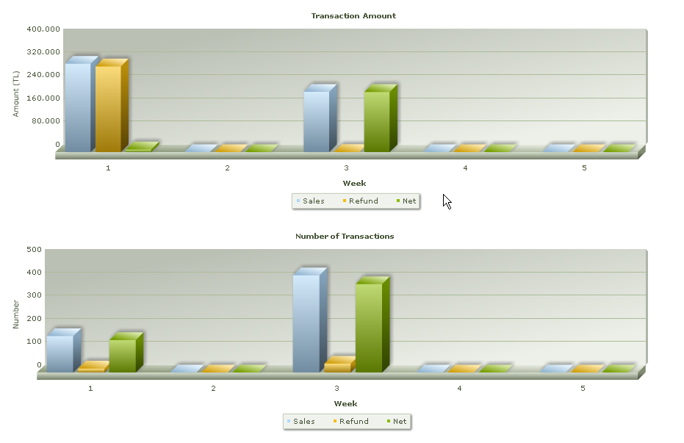

  - Transaction Distribution.
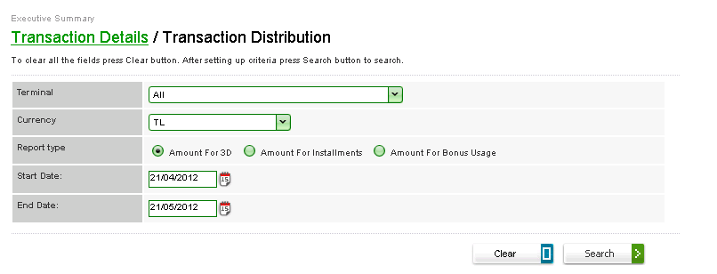
- You can display the transaction distribution for either a specific terminal or all terminals.
- You can choose one of the currency code , given below
  - TL
  - USD
  - EUR
  - JPY
  - GBP
- You can choose report type you want to see the reports.
- You can choose the time period which you want to see the reports of.
Note: You can only display distribution reports for one month periods.
- By clicking the “Search” button, you can display the graphical reports for transaction amount and number of transaction.

When you select the “Amount of 3D” as a report type, you can display the percentage of the 3D secure levels. Report contains 3 levels as you see below.
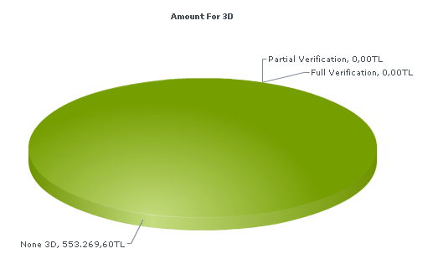

When you select the “Amount of Installments” as a report type, you can display the percentage of installment counts one by one

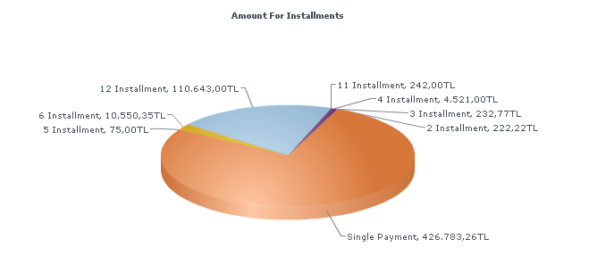

When you select the “Amount of Bonus Usage” as a report type, you can display the percentage of the bonus usage daily.

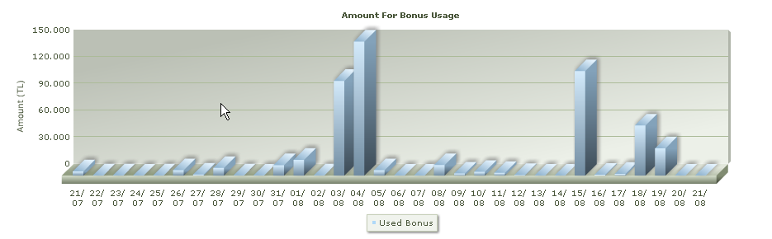

View Orders
To view the all orders completed successfully you can follow the steps below.
- Click the “Orders” menu tab on the left side.
- Choose the “Order search” option.
- “Order search” screen will be viewed as below.
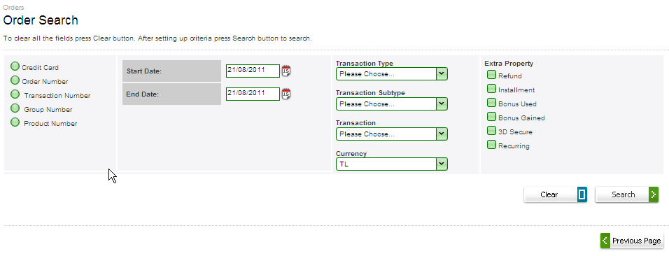

- You must choose one of these options, given below.
  - Credit card
  - Order number
  - Transaction number
  - Group number
  - Product number
- You can choose time period you want to view the order list
- You must choose among those listed in “Transaction type”, given below.
  - Sales
  - Extended credit
  - Preauthorization
  - DCC inquiry
  - Identity verification
- You can choose among those listed in ‘Transaction sub type”, given below.
  - DCC sales
  - Statement verification
  - SMS verification
- You can chose among those listed in “Transaction”, given below.
  - E- commerce
  - Manual entry
- You can choose among those listed in “Currency”.
- You can choose extra Property on the right side of screen, given below.
  - Refund
  - Installment
  - Bonus used
  - Bonus gained
  - 3D secure
  - Recurring

- Click the “Search” button , and then successfully completed orders are listed if there are any definition matching you criteria. You can find detailed data of the orders, details are given below.

  - Transaction type
  - Transaction subtype
  - Order number
  - Transaction number
  - Transaction date
  - Credit card number
  - Order amount
  - Installment
  - Transaction status
  - Verification
  - Special fields rows

Note: The Special fields’ rows can extend on ‘Special Field Selection” menu by merchant users.

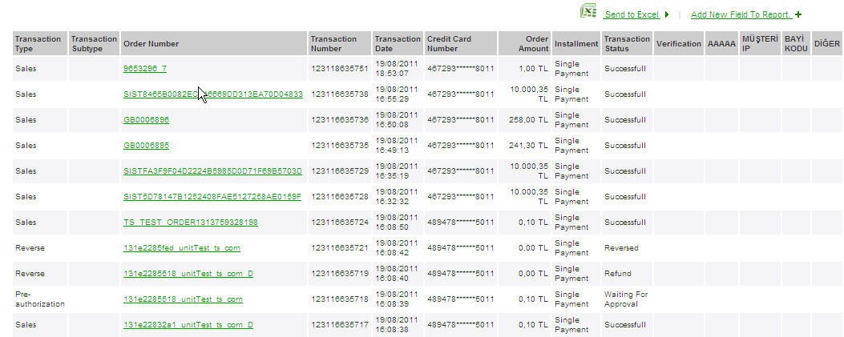

- You can transfer the data to excel by clicking “Send to Excel” button.

- When clicked any of the order records listed (over green link label), you will be directed to the order details page. As seen on the screenshot below you can view transaction details, invoice address and Delivery address( if there are any address info comes)

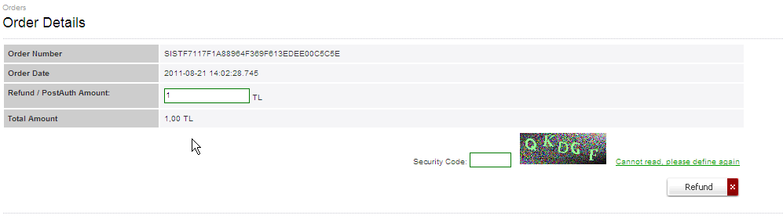
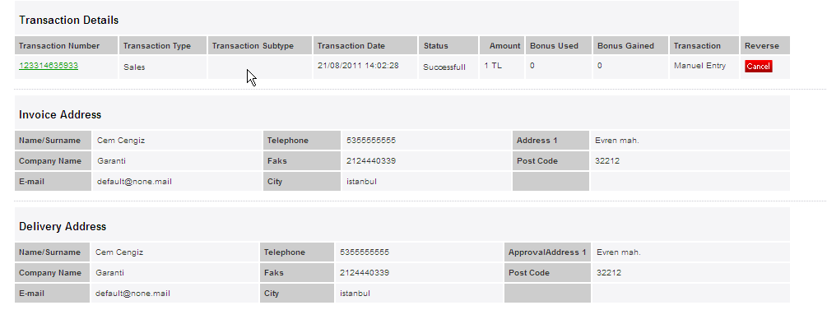

- You can cancel, refund and close preauthorized transactions on the same screen.
- When clicked any of the transaction numbers listed (over green link label) in “Transaction Number”, you will be directed to the Transaction Details page. You will see transaction status and additional property for payment and order details.

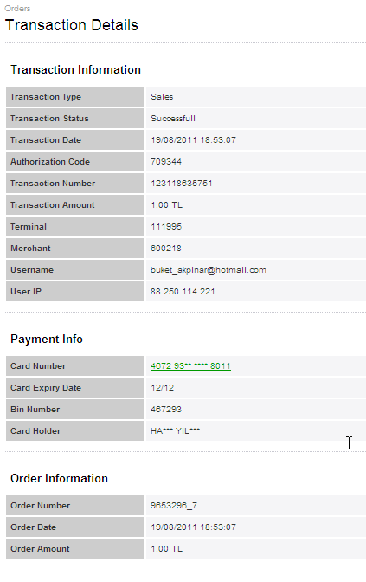
14. When clicked card number (over green link label) in “Payment Info”, you will be directed to the Transaction Statistics page. You will see cards payment history in terms of transactions status daily and weekly.
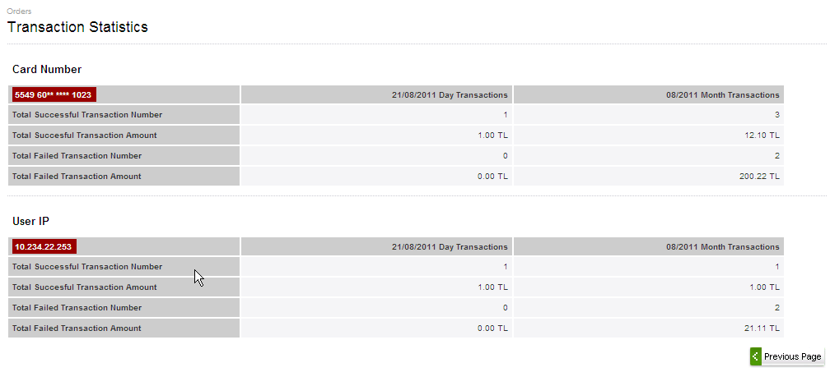

View Approved Orders
To view the approved orders completed successfully you can follow the steps below.
- Click the “Orders” menu tab on the left side.
- Choose the “Approved” option.
- “Approved Orders” screen will be viewed as below.
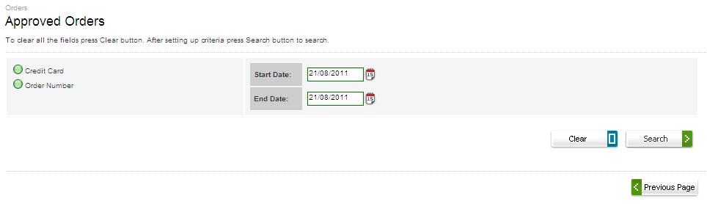
- You must choose one of these option, given below.
  - Credit card
  - Order number
- You can choose the time period which you want to view list of.
- Click the “Search” button , you will see the approved order list.

View Pending Orders

To view the pending orders you can follow the steps below.
- Click the “Orders” menu tab on the left side.
- Choose the “Pending” option.
- “Pending Orders” screen will be viewed as below.
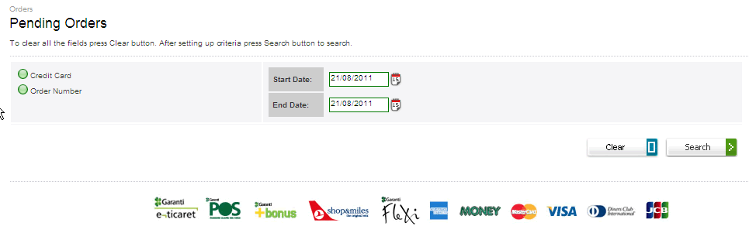

- You must choose one of these option, given below.
  - Credit card
  - Order number
- You can choose the time period which you want to view list of.
- Click the “Search” button , you will see the pending orders list.

View Refundable Orders

To view the refundable orders, you can follow the steps below.
- Click the “Orders” menu tab on the left side.
- Choose the “Refundable” option.
- “Refundable Orders” screen will be viewed as below.
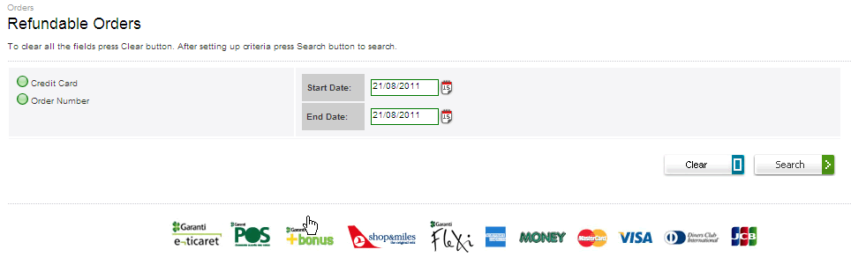

- You must choose one of these option, given below.
  - Credit card
  - Order number
- You can choose the time period which you want to view list of.
- Click the “Search” button; you will see the pending orders list.
- There are check boxes listed beside transactions and the selected transactions can be refunded collectively.

View Reversible Orders

To view the reversible orders, you can follow the steps below.
- Click the “Orders” menu tab on the left side.
- Choose the “Reversible” option.
- “Reversible Orders” screen will be viewed as below.
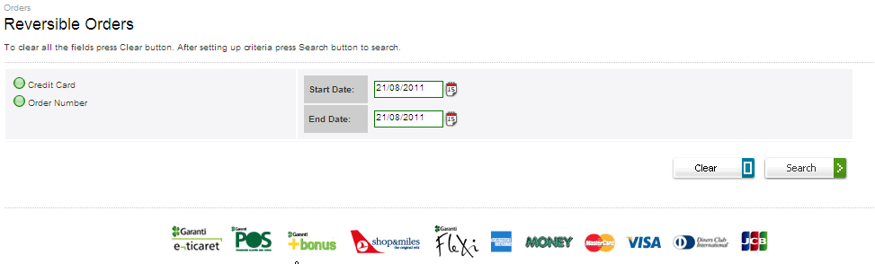

- You must choose one of these option, given below.
  - Credit card
  - Order number
- You can choose the time period which you want to view list of.
- Click the “Search” button , you will see the pending orders list.
- There are check boxes listed beside transactions and the selected transactions can be reversed collectively.

View Recurring Orders

To view the reversible orders, you can follow the steps below.
- Click the “Orders” menu tab on the left side.
- Choose the “Reversible” option.
- “Recurring Orders” screen will be viewed as below.
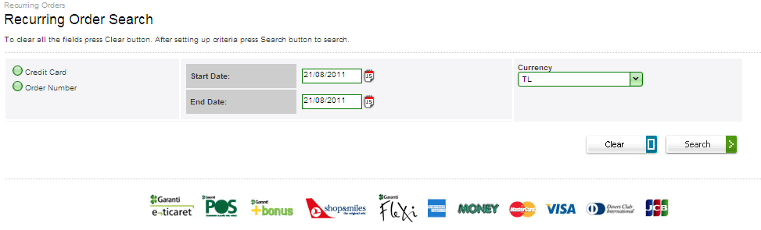

- You must choose one of these option, given below.
  - Credit card
  - Order number
- You can choose the time period which you want to view list of.
- Click the “Search” button , you will see the pending orders list.
- Recurring orders waiting on terminal are shown in the recurring orders menu including details.
- First a search field appears on the screen. Search criteria as sought in this field are listed as follows.
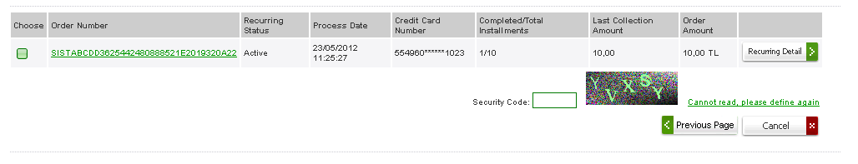
- The recurring uncompleted transactions have a check box shown beside. By clicking the check box and selecting cancel button all the future recurring transactions will be cancelled.
- To go to the recurring transactions details page, click Recurring Detail button
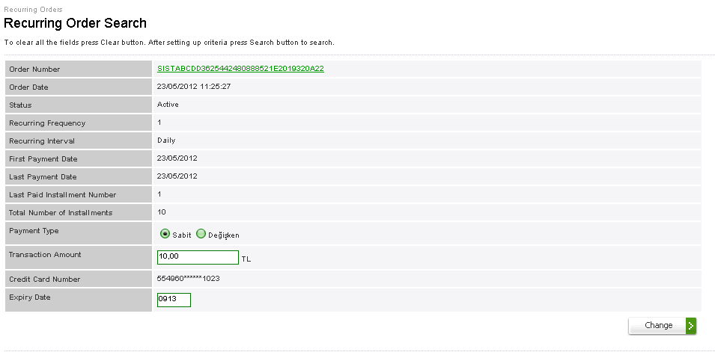

- There are three parts on the recurring order search screen. First part shows the order details.
- You can update the card expire date.
- You can change Payment type form “Regular Payment” to “Irregular Payment”

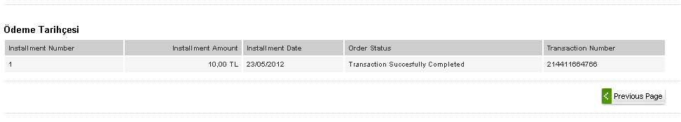
- Second part shows the “Payment History”, you will see the recurring transaction status.
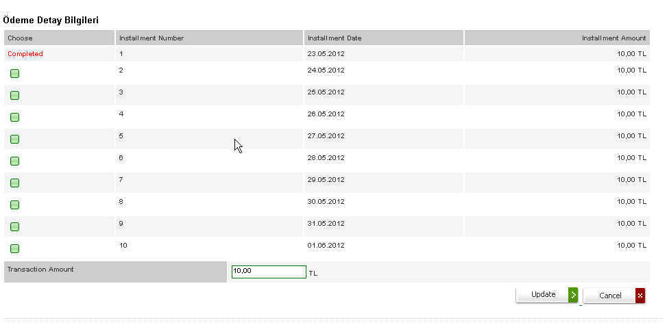
- Last part of the “recurring order search” page shows payment details for variable recurring orders. The recurring uncompleted transactions have a check box shown beside. By clicking the check box and entering the new transaction amount, old amount value for recurring transaction will be changed.

View Waiting Recurring Orders

To view the Waiting Recurring Orders, you can follow the steps below.
- Click the “Orders” menu tab on the left side.
- Choose the “Waiting Recurring” option.
- “Waiting Recurring Transactions” screen will be viewed as below.

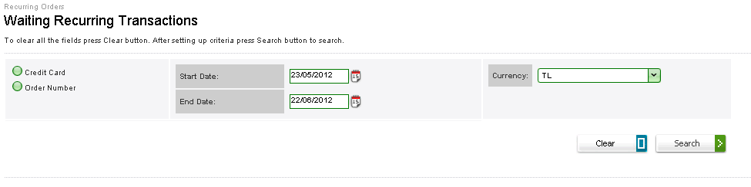

- You must choose one of these option, given below.

  - Credit card
  - Order number
- You can choose the time period which you want to view list of.
- Click the “Search” button , you will see the pending orders list.
- Recurring orders waiting on terminal are shown in the recurring orders menu including details.
- First a search field appears on the screen. Search criteria as sought in this field are listed as follows.

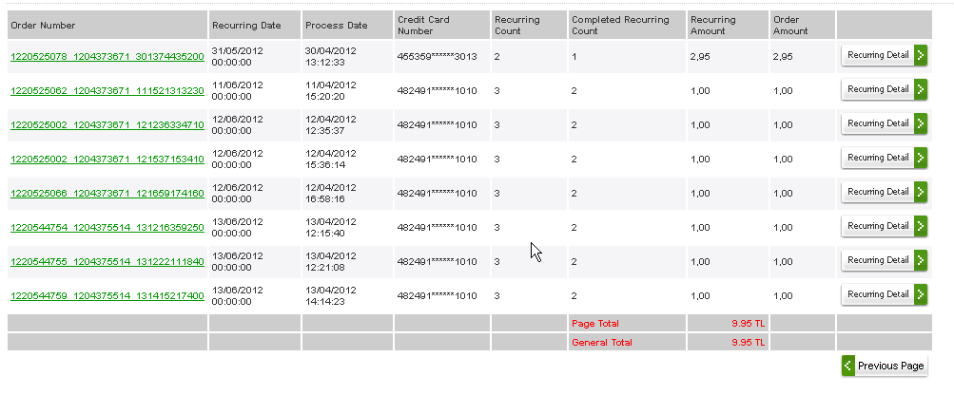
- The waiting recurring transactions will be viewed.
- To go to the recurring transactions details page, click Recurring Detail button

View Transactions
To view all transaction (uncompleted, completed), you can follow the steps below.
- Click the “Transaction” menu tab on the left side.
- Choose the “Transaction Search” option.
- “Transactions Search” screen will be viewed as below.
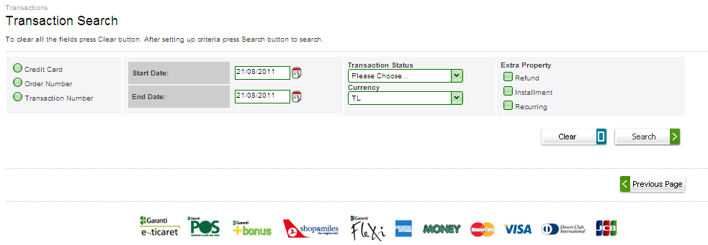

- You must choose one of the options , given below
  - Credit card
  - Order number
  - Transaction number
- You can choose the time period which you want to view list of.
- You must choose among those listed in “Transaction Status” , given below
  - Approved
  - Failed
  - Rejected
- You can choose among those listed in the currency, given below.
  - TL
  - USD
  - EUR
  - JPY
  - GBP
- You can choose extra property among those listed on the right side of screen, given below.
  - Refund
  - Installment
  - Recurring
- Click the “Search” button , you will see transactions are listed if there are any definition matching you criteria. You can find detailed data of the transactions, given below.

  - Transaction type
  - Transaction subtype
  - Order number
  - Transaction number
  - Transaction date
  - Credit card number
  - Order amount
  - Installment
  - Transaction status
  - Verification
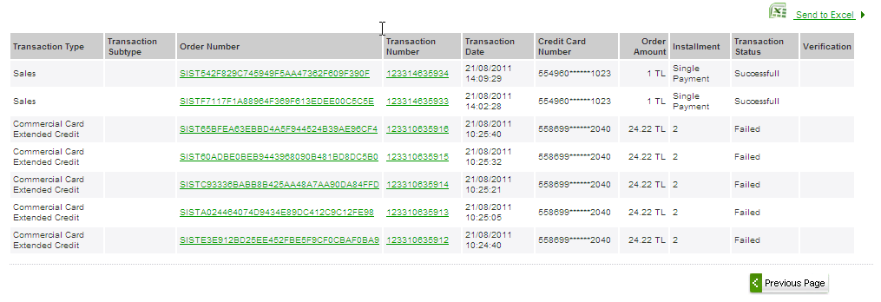

- You can transfer the transaction list to excel by clicking the “Send To Excel” button on the same screen.

Manual Transactions
To make manual transactions supported by GVPS platform, you can follow the steps below.
- Click the “Manual Transaction” menu tab on the left side
- Choose the “Manual Transaction Entry” option.
- “Manual Transaction Entry” screen will be viewed as below.
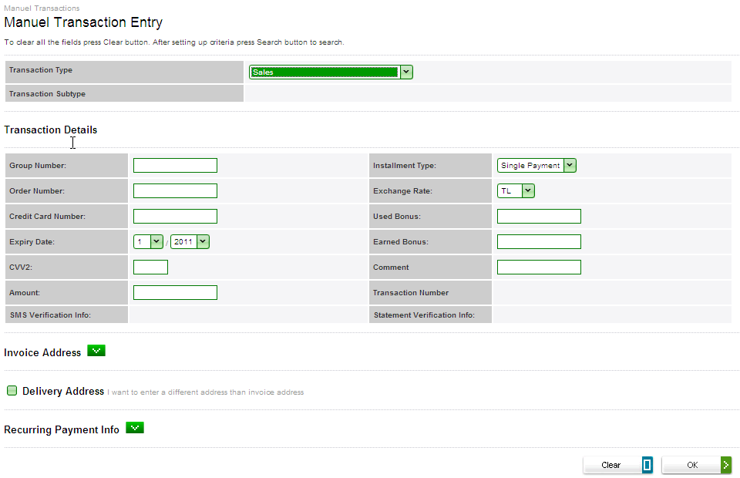

- You can choose among those listed in “transaction types” , given below
  - Sales
  - Sales Using extended credit
  - Preauthorization using extended credit
  - Preauthorization
  - Post authorization
  - Refund
  - Reversal
  - Bonus inquiry
- You can choose among those listed in “transaction sub types” for preauth transaction type, given below
  - Standard
  - Statement
  - SMS
- Depending on transaction type, spaces that need to be completed are shown on the screen.
- By filling these spaces and clicking “OK” button transaction is carried out and transaction outcomes are listed in transaction detail page.
- For transaction on manual transaction screen there is a space provided for addresses information. User may enter the client addresses information in the following space.
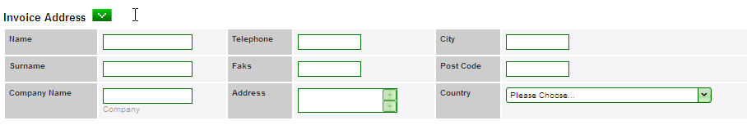

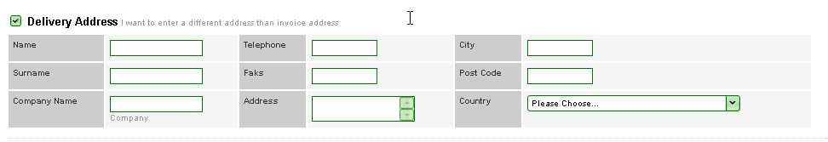

- To have recurring transactions there is a recurring payment part provided on the same screen.

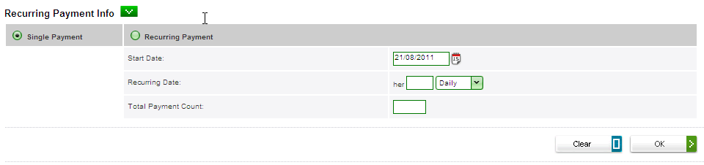

- To make a recurring transaction, user has to choose recurring payment mark and fill the parameters corresponding to the transaction.

Mass Approvals
To approve all your pending transactions with the new collective approval process you can define a job. The procedures for defining new process will explain in Define new job section.

Define New Job

- Click the “Mass approvals” menu tan on the left side
- Choose the “new job” option.
- There are three steps to complete definition of new job, you will see screens as below.

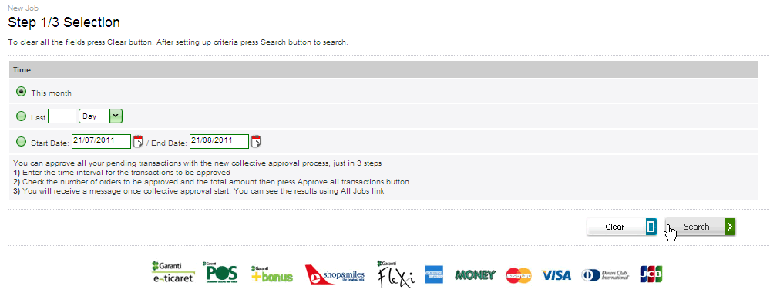

- You can choose the time period among those listed on page , given below
  - This month
  - Last day /week /month
  - Start date and end date
- Click the “search” button , you will see the number of orders to be approved and the total amount

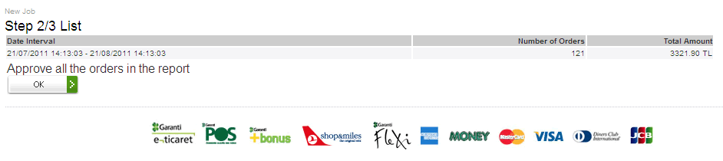
- Check the number of orders to be approved and the total amount , then click “OK” button to Approve all transactions
- You will receive a message once collective approval start. You can see the results using All Jobs link. The procedure for listing all will explain in view all job section.

View All Job

- Click the “Mass approvals” menu tan on the left side
- Choose the “All jobs” option.
- “Mass approval” screen will be viewed as below. You can find data for the jobs defined; including job number, status, user, reporting time, approval start and finish time, total transaction amount for approved, rejected and pending and all total transaction amount.
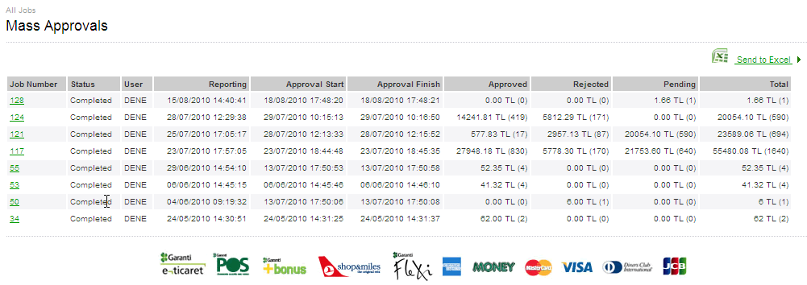

- When clicked any of the job listed (over green link label), you will be directed to the detailed information page for the job. As seen on the screenshot below you can view details of the job and go to order details or transaction details pages.

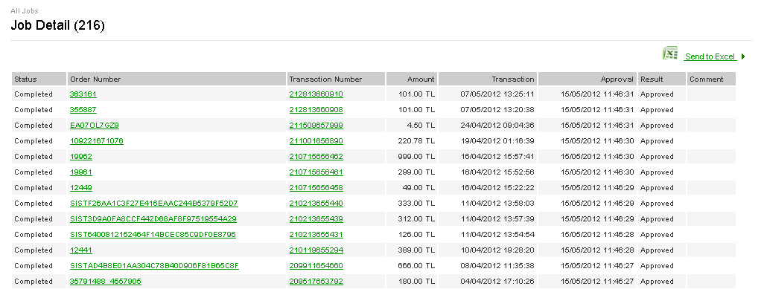

View Product
To view product details comes with transaction, you can follow the steps below
- Click the “Products” menu tab on the left side.
- Choose the “Product Search” option.
- “Product Search” screen will be viewed as below.
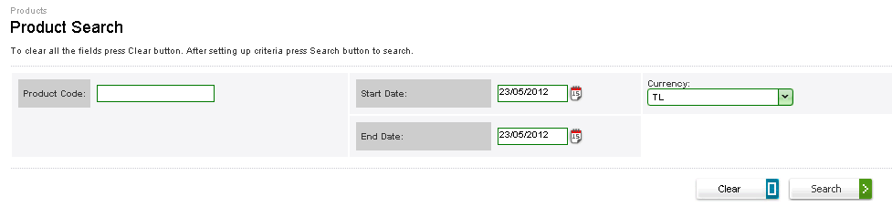

- Enter the product code or name.
- Choose the time period you want to view list of.
- Choose the currency you want to view list of.
- Click the “search”, you will see the product list; including product code, product subscription, if there are any product matching you criteria.

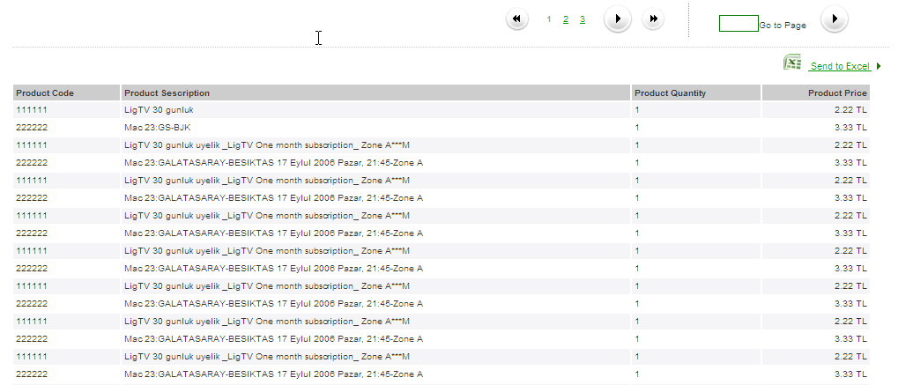

End Of Day
End of day menu contains end of day transactions details concerning virtual pos.

- You can list the not entered end of day data in “Active End of Day” menu. The procedure to list the data will explain in View Active End Of Day section .
- You can report the batch based end of day request on “End of Day Reports” screen. The procedure to list of the batch end of day requests will explain in View End of day Reports section.

View Active End of Day

In order to list the details for transactions not entered the end of day, you can follow the steps below.
- Click the “End of Day” menu tab on the left side.
- Choose the “Active End of Day” option.
- “Active End of Day” screen will be viewed below.

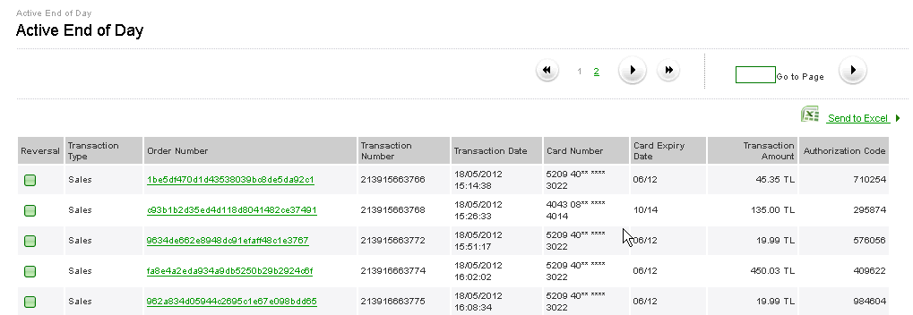

- There are check boxes listed beside the transactions. Cancellation can be applied collectively through signed transactions.

View End of Day Reports

In order to list the reports of the batch based end of day, you can follow the steps below
- Click the “End of Day” menu tab on the left side.
- Choose the “End of Day Reports” option.
- “End of Day” screen will be viewed below.
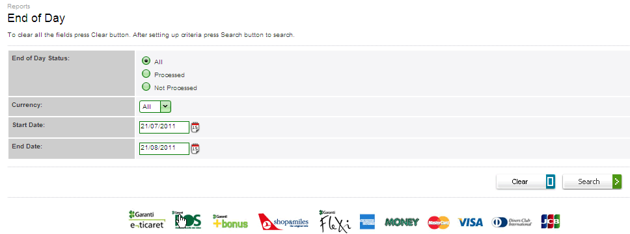

- Choose the end of day status.
- You can choose the currency among those listed.
- You can choose the time period you want to reports of.
- Click the “search” button; you will see batch lists for end of day reports including ; end of day file number , End of day status, end of day date , refund amount , number of refunds, sales amount , number of sales, and total amount.

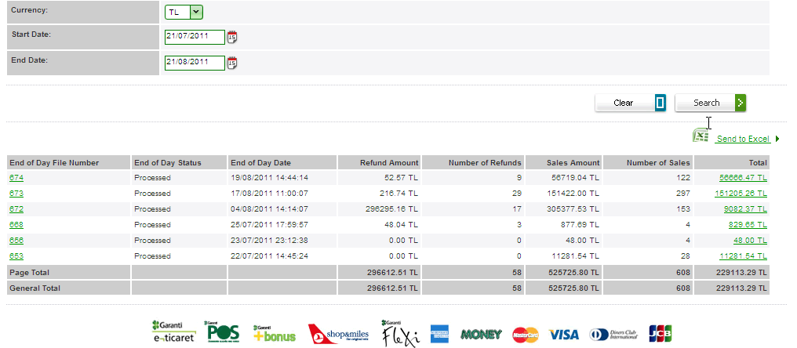 8. When you select the specific currency code, you can view summations, otherwise summation will not be viewed.

Administration
Merchant user is authorized as explained in before sections. Contents of the administration have limited options in comparison with merchant admin. The procedures are almost same with merchant admin’s pages and will explain in next sections.

Password/Keyword Update

One option is supplied for user password management
  - Password /keyword change

The steps for the update operation are explained below.

- Password change operation can be handled only for the session owner user (user logged in at that moment). To change your password /keyword, click “Administration” menu tab on the left side.
- Choose “Password /keyword Update” menu options.
- Select the transaction type you want to update the value of.
- After entering the old and new password values, click “Update” button. If you have follewed the password format rules for the new password, the password shoul be updated succesfully.
Note: The Update procedure is the same for password and keyword.

BIN List

To view the list of the BIN data, you can follow the steps below.
- After successful Login to GVPS application, click the “Administration” menu tab on the left side.
- Choose the “BIN list” option.
- “Bin Listing” screen will appear below.

- Choose the group among those listed, given below
  - Garanti
  - Bonusnet
- You can choose the Bank which is the members of the BONUS brand.
- You can choose the organization you want to view lists of.
- You can choose the card type you want to view lists of.
- After all selection is completed, you will see the list of BIN matched with your criteria.

- You can transfer the BIN list to excel by clicking the “Send to Excel” button on the same screen.

Special Field Selection

In order to add extra field to listing pages, you can follow the steps below
- After successful login to GVPS application, click the “Administration” menu tab on the left side.
- Choose the “Special Field Selection” option.

- “Report Display Settings” screen will appear below.

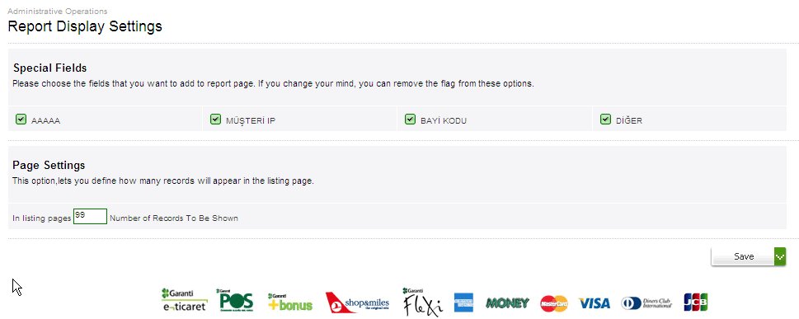

- Choose those listed field you want to add, so the data will be located on the reports with corresponded data.

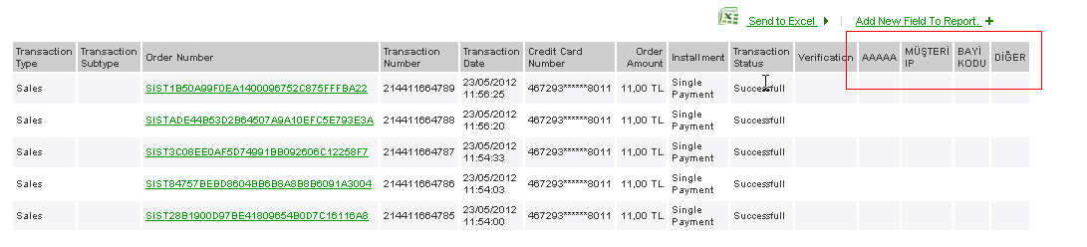

Define Source Base Security Definitions
There are two options are supplied for security definitions
- Source based security definition
- Blacklist definition

You can define the number of transactions or total amount of transactions for per day, per week or per month for each terminal. Limit of the transactions can be defined based on the IP, card number and BIN. To define Source based security conditions you can follow the steps below
- Click the “Security Definitions” tab on the left side.
- Choose the “Source Based Definitions” options.
- “Source Based Definition” screen will be viewed as below.

- You can chose one of the definition type, given below
  - General : To define working conditions for selected source code
  - Spesific : To define working conditions for one the source code . When you select the definition type as specific, you must be enter value for source number field.
- You can choose one the source code which you want to define working conditions definitions of , given below
  - IP
  - Card number
  - BIN
- After all value selection, you can save you definitions by clicking “Save”
button.

Note: You cannot remove the source based security definition already defined by Garanti admin.

View And Update Source Based Security
To list the source based security definition, you can follow the steps below.

- Click the “Security Definition” tab on the left side.
- Choose the “Source Based Definition Listing” option.
- “Source Based Definition Listing” screen will appear below. You can list the source based definition based on the terminal.
- Select the terminal which you want to view source based definition lists of.
- Choose the value for definition type , source code and enter source number(the selection of value for these field is optional)
- After all selection is completed, you can list the source based definitions by clicking “Search” button, if there are any.
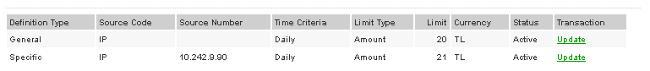

- When clicked any of the records listed (over the green update link label), you will be directed to the update page for the source based definition records. As seen on the screenshot below.
- You can only update limit and status value by clicking “Update” button.

Note: You cannot remove the source based definition already defined. To update the working condition for source code you need to set the status as closed and redefine the working conditions on “Source Based Definition” menu.

Define Blacklist
You can prevent the any transaction based on source code (IP, card number). In order to define whether source code in blacklist or not, you can follow the steps below.

- Click the “Security definitions” tab on the left side.
- Choose the “Blacklist Definition” option.
- “Blacklist Definition” screen will appear below.
- You can choose source code which you want to prevent the any action of.
- You can enter the specific source number
- After statu selection , click the “Save” button.

View Blacklist
- To check whether a source code is in blacklist or not, choose “Blacklist” option under “Security definitions” menu.
- Enter the definition type you want to search
- Enter the source code you want to search in specific value
- Enter the blacklist status (in blacklist or not )
- Click the “search button , and then the blacklist is listed.

View BonusPay Reports
You can list the BonusPay Transaction according to criteria selected.

BONUSPAY: It is way to payments that the transactions can be occurred on credit card, debit card or account interrelated to GSM. GSM number is mandatory field for BonusPay transactions.

In order to list Bonuspay transaction, you can follow the steps below

- After successful login to GVPS application, click the ‘BonusPay’ menu tab on the left side.
- Choose “Bonuspay reports” option.
- “Bonuspay Reports” screen will see below.
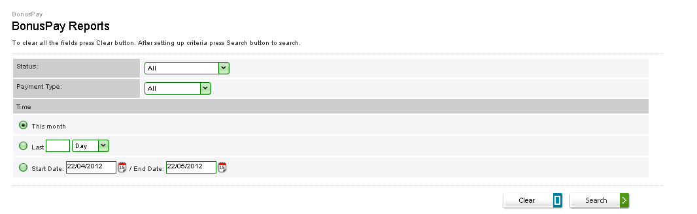
- You can choose the status you want to report of, given below.
  - Pending for approval
  - Completed
  - Void (Firm)
  - Expired
  - Void User
  - Failed
- You can chose the payment type you want to report of , given below.
  - Credit card
  - Debit card
  - Current account
- You can choose the time interval you want to report of.
- Click the “Search” button; you will be viewed as below. You can find data for the Bonuspay transactions; including order number, transaction types, firm , Bonuspay references number, transaction status, initial amount ,net amount , transaction date ,mobile phone number ,installment count

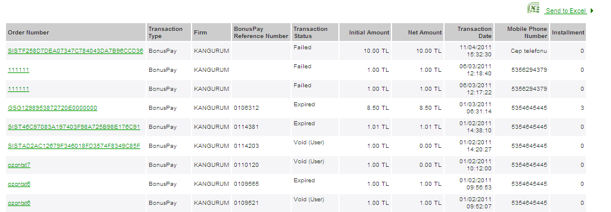

- When clicked any of the order number listed (over green link label), you will be directed to the “Transaction Details Page”.

